Bulletin Template:

We’re excited to announce that you can now give using digital wallets:
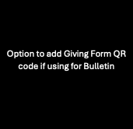
- Apple Pay
- Google Pay
- Venmo
- PayPal

Simply scan the QR code or visit our website to give securely from your smartphone.
Thank you for supporting our ministries and mission! If you have any questions, feel free to contact [Church Office Contact Info].

